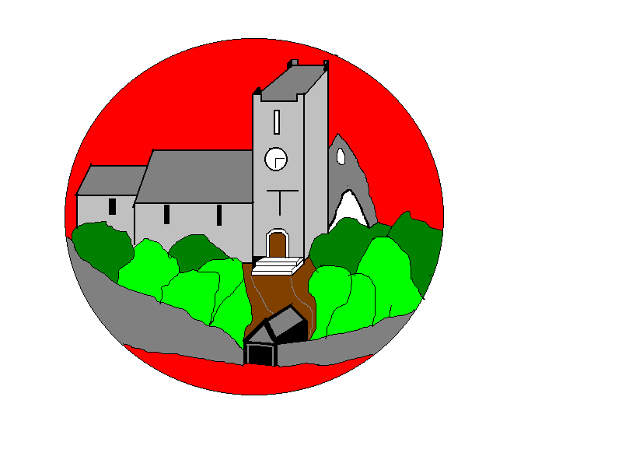

**MFL**In French, children will to say the capital cities of the UK. They will learn about intonation used in French. Finally, we will look at words ending with a consonant and how they are silently pronounced.

**History**Our topic is called **‘Why did the Ancient Egyptians build pyramids?**’

**Science**

Our topic in Science this half term is Sound. The children will learn through investigation how sound is made, how we hear, how distance can affect sound and how the pitch of sound can change.

**English**

Our reading book this half term is I was a Rat! by Philip Pullman. Our writing will focus around narratives, persuasive letter writing and a diary recount. Our grammar focus will be using conjunctions, apostrophes for singular possession and pronouns to avoid repetition in Year 3. In Year 4, the children will learn to use fronted adverbials, apostrophes for singular and plural possession and expanded noun phrases. Please make sure you sign the reading record so your child can collect Diddidots.

**RE**Our RE topic is **‘What is the trinity?’**

**PE**

The children are very lucky to have a coach for gymnastics this half term. They will be learning new ways to travel, balance, roll, jump and land. In our other lesson, the children will learn throwing, catching and striking tactics in dodgeball.

Year 3 / 4

Curriculum Information

Autumn 2 2022

**Relationship Education/ PSHE**

Our PSHE this term focuses on maintaining a balanced lifestyle; oral hygiene and dental care. It then moves onto forming and maintaining positive friendships, including in the online. Finally, we will learn what makes a community and how responsibilities are shared.

**DT**

Our DT topic is Heathy and Varied Diet (Food). The children will follow safety and hygiene procedures to design and produce either a pizza or a toasted sandwich.

**Music**In Music the children will sing a wide range of unison songs varying in styles of pitch and structure. They will perform as a choir in school assembly and use actions confidently.

**Computing**

In Digital Literacy the children will learn about the power of their words (cyberbullying). Our other focus will be Stop Frame Animation (Creating Media) where the children will create a stop frame animation.

**Maths**

This half term we will be focusing on Fractions, Measure, Time and Shape. It is important that all children are continuing to practice their times tables. *Year 3 should be fluent with their 2s,3s, 5s & 10s.*

*Year 4 should be fluent with their 2s, 3s, 4s, 5s, 8s & 10s and developing their 6s and 7s.*