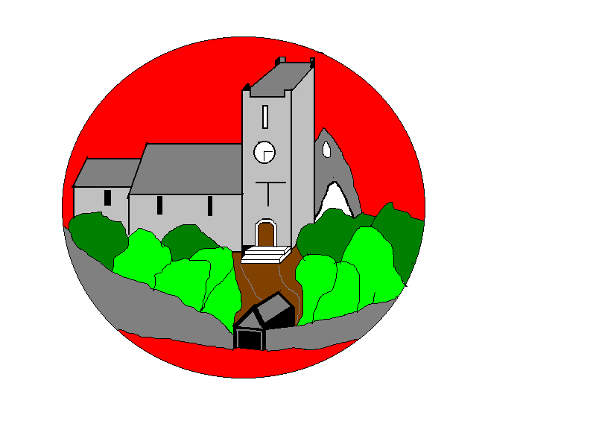

**Computing**

In Digital Literacy the children will focus on privacy and security. In our other topic the children will create branching data bases.

**RE**Our RE topic is **‘Why do Christian’s call the day Jesus died Good Friday?’**

**Relationship Education/ PSHE**

Our topics this half term include responding to hurtful behaviour; managing confidentiality; recognising risks online (Safe Relationships) and how data is shared and used (Media Literacy and Digital Resilience).

**DT**

In our DT topic, we will design, make and evaluate shell structures using a computer aided design software called Techsoft.

**PE**

As part of the National Curriculum the children will continue swimming lessons on a Friday afternoon. Handball is the focus of our other PE lesson.

Year 3 / 4

Curriculum Information

Spring 2 2023

**History -** Our topic is called **‘Why did the Romans march through County Durham?’**

**MFL**In French the children will write sentences about animals with fronted adverbials, nouns and adjectives. They will know that a French adjective must agree with the gender of the noun it is describing and can modify adjectives. Children will be able to identify a question in French, both in speech and in writing.

**Maths**

This half term we will be focusing on fractions, measurement, money and time. It is important that all children are continuing to practice their times tables. *Year 3 should be fluent with their 2s,3s, 4s, 5s & 10s and developing their 8s.*

*Year 4 should be fluent with all their times table knowledge.*

[www.timestables.co.uk](http://www.timestables.co.uk) is a great website to support their learning.

**Music**In music the children will become more skilled in improvising (using voices, tuned and untuned percussion, and recorder), inventing short ‘on-the-spot’ responses using a limited note range.

**Science-** Our topic in Science this half term is electricity. The children will learn to identify common appliances that run on electricity. Construct a simple series electrical circuit, identifying and naming its basic parts, including cells, wires, bulbs, switches and buzzers.

They will identify whether or not a lamp will light in a simple series circuit, based on whether or not the lamp is part of a complete loop with a battery. As well as recognising that a switch opens and closes a circuit and associate this with whether or not a lamp lights in a simple series circuit.

Finally, they’ll learn to recognise some common conductors and insulators, and associate metals with being good conductors.

**English**

Our reading book this half term is *The Rhythm of the Rain by Grahame Baker-Smith*. Our writing will focus around setting description/narratives and explanation texts. Our grammar focus will be using apostrophes for plural possession, using subordinate clauses and use of effective vocabulary.